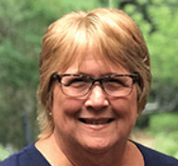
Working Remotely: Carter Ann Rollins
Payroll and Benefits Specialist
Ward and Smith, P.A.

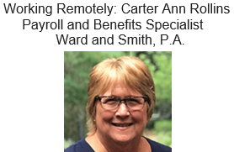
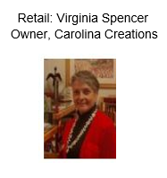
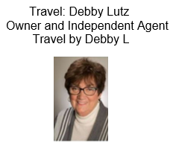
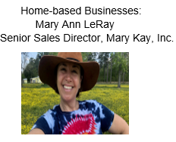

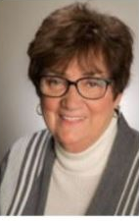
Travel: Debby Lutz
Owner and Independent Agent
Travel by Debby L

Home-based Businesses:
Mary Ann LeRay
Senior Sales Director, Mary Kay, Inc.

Retail: Virginia Spencer
Owner, Carolina Creations
